Practical 2: Specify Inputs, Outputs, State, and Interaction Contracts for CPS Components for Smart Traffic Light System

1. Aim
To design a Cyber-Physical System (CPS) abstraction for a Smart Traffic Light System by specifying the inputs, outputs, internal states, timing requirements, normal-operation contracts, and failure-handling contracts of its major components.
The three CPS components considered are:
- Vehicle/Traffic Sensor
- Traffic-Light Controller
- Traffic-Light Actuator
The practical also defines the interaction contracts between:
- Sensor → Controller
- Controller → Actuator
- Actuator → Controller

2. Objectives
The objectives of this practical are:
- To identify the inputs and outputs of CPS components.
- To define the internal states of each component.
- To represent state transitions for the sensor, controller, and actuator.
- To specify timing requirements for real-time operation.
- To define normal-operation contracts.
- To define failure-handling contracts.
- To specify the information exchanged between CPS components.
- To understand how sensing, computation, actuation, and feedback work together in a CPS.

3. CPS Scenario: Smart Traffic Light System
A Smart Traffic Light System monitors traffic at a road intersection and automatically controls traffic signals according to the detected traffic conditions.
The system uses traffic sensors to detect vehicles and estimate traffic conditions. The traffic-light controller processes this information and determines whether the signal should be RED, YELLOW, or GREEN. The traffic-light actuator receives the controller command and physically operates the corresponding traffic signal.
The basic CPS operation is:
Traffic Environment → Traffic Sensor → Traffic-Light Controller → Traffic-Light Actuator → Traffic Environment
The system is assumed to operate continuously and periodically collect traffic information.
For this practical, the following assumptions are made:
- Traffic information is sampled once every second.
- The sensor must generate a measurement within 100 ms.
- The controller must generate a decision within 50 ms.
- The actuator must execute a valid command within 100 ms.
- Emergency vehicle detection is treated as a high-priority condition.
- Invalid sensor data must not be used for normal adaptive control.
- The actuator provides feedback to the controller after executing a command.

4. Traffic Sensor Abstraction
The traffic sensor observes the physical road environment and converts traffic conditions into digital information for the controller.

4.1 Sensor: Vehicle/Traffic Sensor
Inputs
Input | Description
Vehicle presence | Indicates whether vehicles are detected
Vehicle count | Number of vehicles detected during the sampling period
Sampling trigger | Indicates when a new measurement should be taken
Emergency status | Indicates whether an emergency vehicle is detected
Sensor status | Indicates whether the sensor is operational
At least three inputs are required by the practical; five are specified here to represent the sensor more completely.
Example Input
Vehicle Count = 15
Emergency Status = FALSE
Sampling Trigger = TRUE
Sensor Status = NORMAL

4.2 Sensor Outputs
Output | Description
Vehicle count | Number of detected vehicles
Queue length | Estimated number of vehicles waiting
Emergency status | Indicates emergency vehicle detection
Timestamp | Time at which the measurement was generated
Sensor status | VALID / INVALID / ERROR
Example Output
Vehicle Count = 15
Queue Length = 8
Emergency Status = FALSE
Status = VALID

4.3 Sensor Internal States
The sensor has the following internal states:
State | Description
IDLE | Waiting for a sampling request
SENSING | Detecting vehicles
VALID | Measurement successfully generated
INVALID | Measurement is not reliable
ERROR | Sensor has experienced a failure
Thus, the sensor has more than the required four internal states.
State Transition
The sensor starts in IDLE. When a sampling trigger is received, it enters SENSING. If the measurement is successful, it enters VALID and sends the result to the controller. If the measurement cannot be trusted, it enters INVALID. Hardware or communication failure causes the sensor to enter ERROR.
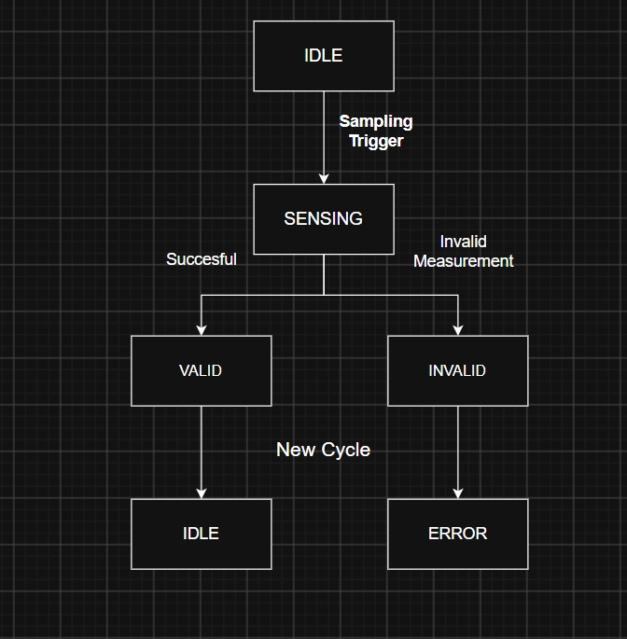
An arrow will be included from INVALID → IDLE if the system retries the next measurement.
Figure 1: State-Transition Diagram of Vehicle/Traffic Sensor

4.4 Sensor Timing Requirement
The traffic sensor has a sampling period of 1 second.
The sensor must generate a measurement within:
Sensor response time ≤ 100 ms
Therefore, after receiving a valid sampling trigger, the sensor should provide the traffic measurement within 100 ms.

4.5 Sensor Normal-Operation Contract
The sensor must guarantee that:
- A measurement is generated for every valid sampling request.
- The measurement contains a timestamp.
- Vehicle count and queue information are provided in the defined format.
- Emergency vehicle detection is clearly indicated.
- Invalid measurements are marked as INVALID.
- Corrupted or incomplete data is not sent to the controller.
- A valid measurement is produced within 100 ms.
Sensor Contract
Input:
- Sampling trigger
- Vehicle presence
- Sensor status
Output:
- Vehicle count
- Queue length
- Emergency status
- Timestamp
- Validity status
Guarantee:
If the sensor is operational, a valid traffic measurement is generated within 100 ms of the sampling request.

4.6 Sensor Failure-Handling Contract
If the sensor fails or produces unreliable data:
- The sensor marks the measurement as INVALID or ERROR.
- Invalid data is not presented as a valid traffic measurement.
- The sensor status is communicated to the controller.
- The controller uses its predefined safe operating mode.
- The sensor attempts to resume normal sensing during the next valid operating cycle.

5. Traffic-Light Controller Abstraction
The traffic-light controller is the decision-making component of the CPS. It receives traffic information from the sensor, processes it, and generates a command for the traffic-light actuator.
5.1 Controller Inputs
Input | Description
Vehicle count | Number of vehicles detected
Queue length | Number of vehicles waiting
Emergency status | Indicates emergency vehicle detection
Sensor status | Indicates whether the received data is valid
Timestamp | Time of the sensor measurement
Timing data | Current signal timing information
Example Input
Vehicle Count = 15
Queue Length = 8
Emergency Status = FALSE
Sensor Status = VALID

5.2 Controller Outputs
Output | Description
Light command | RED / YELLOW / GREEN command
Command timestamp | Time at which command was generated
Controller status | NORMAL / EMERGENCY / FAULT
Sequence number | Identifier for the command
Example Output
Light Command = GREEN
Command Timestamp = 10:30:05.050
Status = NORMAL
Sequence Number = 101

5.3 Controller Internal States
The controller maintains the following states:
State | Description
WAITING | Waiting for new sensor information
PROCESSING | Processing traffic information
GREEN | Green signal command is active
YELLOW | Yellow transition is active
RED | Red signal command is active
EMERGENCY | Emergency traffic condition is being handled
FAULT | Controller has detected an abnormal condition

5.4 Controller Decision Logic
The controller uses valid traffic information to select an appropriate signal command.
Under normal conditions:
- High traffic may result in an appropriate GREEN phase within its configured limit.
- Low traffic follows the normal signal sequence.
- A GREEN phase changes to YELLOW before the next signal phase.
- The controller never generates conflicting GREEN commands.
If an emergency vehicle is detected, the controller enters the EMERGENCY state and applies the predefined emergency-control procedure.
If sensor data is INVALID or ERROR, the controller does not use that measurement for normal adaptive control and enters a predefined safe/fallback mode.

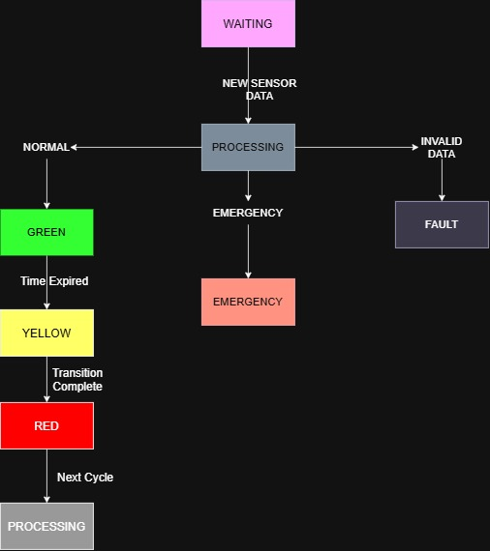
Figure 2: State-Transition Diagram of Traffic-Light Controller (via draw.io)
5.5 Controller Timing Requirement
The controller must process a valid sensor measurement and generate the required traffic-light command within:
Controller response time ≤ 50 ms
This ensures that the controller does not introduce a significant delay between sensing and control.

5.6 Controller Normal-Operation Contract
The controller must guarantee that:
- Only valid sensor measurements are used for normal control.
- Vehicle count and queue information are processed before making an adaptive decision.
- Emergency conditions are handled with higher priority.
- Conflicting GREEN commands are not generated.
- Every command contains a timestamp or sequence number.
- Signal transitions follow the predefined sequence.
- A control command is generated within 50 ms.
Controller Contract
Input:
- Vehicle count
- Queue length
- Emergency status
- Sensor status
- Timestamp
- Timing data
Output:
- Light command
- Command timestamp
- Sequence number
- Controller status
Guarantee:
For every valid traffic measurement, the controller generates the appropriate traffic-light command within 50 ms.

5.7 Controller Failure-Handling Contract
If the controller detects invalid data or an internal failure:
- It enters the FAULT or safe state.
- Adaptive traffic control is disabled.
- A predefined safe traffic-light sequence is used.
- The fault condition is recorded or communicated.
- Normal operation resumes after valid operation is restored.
The controller must not generate unpredictable traffic-light commands during a fault.

6. Traffic-Light Actuator Abstraction
The traffic-light actuator converts the digital command received from the controller into physical traffic-light operation.
6.1 Actuator Inputs
Input | Description
Light command | RED / YELLOW / GREEN command
Command timestamp | Time when the command was generated
Enable signal | Allows actuator operation
Safety signal | Indicates whether activation is safe
Sequence number | Identifies the command
Example Input
Light Command = GREEN
Enable = TRUE
Safety = TRUE
Sequence Number = 101

6.2 Actuator Outputs
Output | Description
Light status | Current physical traffic-light state
Feedback | Indicates successful or failed execution
Actuator status | ON / OFF / FAULT
Fault indication | Indicates actuator failure
Example Output
Light Status = GREEN
Actuator Status = ON
Feedback = SUCCESS
Fault = FALSE

6.3 Actuator Internal States
The actuator has the following states:
State | Description
RED | Red traffic signal is active
YELLOW | Yellow traffic signal is active
GREEN | Green traffic signal is active
SWITCHING | Actuator is changing between signal states
FAULT | Actuator cannot safely execute the command

: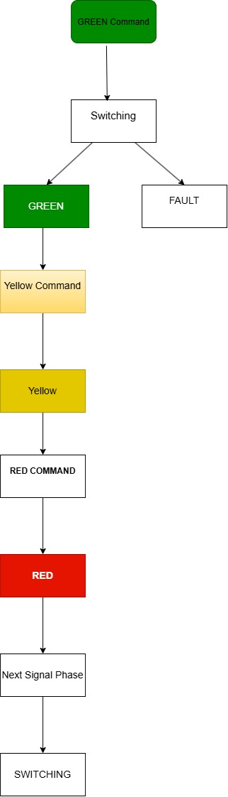
Figure 3: State-Transition Diagram of Traffic-Light Actuator
6.4 Actuator Timing Requirement
The actuator must execute a valid traffic-light command within:
Actuator response time ≤ 100 ms
This ensures that the physical traffic signal follows the controller decision within the required time.

6.5 Actuator Normal-Operation Contract
The actuator must guarantee that:
- Only valid RED, YELLOW, or GREEN commands are accepted.
- Safety conditions are checked before activation.
- The requested traffic-light state is physically activated.
- The actual light status is reported.
- Successful execution is reported through feedback.
- Failed execution is reported as a fault.
- The command is executed within 100 ms.
Actuator Contract
Input:
- Light command
- Command timestamp
- Enable signal
- Safety signal
- Sequence number
Output:
- Light status
- Feedback
- Actuator status
- Fault indication
Guarantee:
If the actuator is enabled and the safety condition is satisfied, a valid traffic-light command is executed within 100 ms and the resulting status is reported.

6.6 Actuator Failure-Handling Contract
If the actuator cannot execute the received command:
- It enters the FAULT state.
- The physical signal is maintained or changed to the predefined safe state.
- A FAULT status is sent to the controller.
- The controller does not assume successful execution.
- The actuator remains in the fault state until recovery.

7. Interaction Contract
The interaction contract defines how the three CPS components communicate.
The practical requires three interactions:
- Sensor → Controller
- Controller → Actuator
- Actuator → Controller

7.1 Sensor → Controller
The sensor sends traffic measurements to the controller.
Data Exchanged
Data | Description
Vehicle count | Number of detected vehicles
Queue length | Estimated waiting vehicles
Emergency status | Emergency vehicle detection
Timestamp | Measurement generation time
Sensor status | VALID / INVALID / ERROR
Contract
The sensor must provide valid and timestamped traffic information to the controller within 100 ms of the sampling request.
If the measurement is invalid, the sensor must clearly indicate its INVALID or ERROR status.
The controller must not use invalid measurements for normal adaptive control.

7.2 Controller → Actuator
The controller sends traffic-light commands to the actuator.
Data Exchanged
Data | Description
Light command | RED / YELLOW / GREEN
Timestamp | Time command was generated
Sequence number | Command identifier
Controller status | NORMAL / EMERGENCY / FAULT
Contract
The controller must generate a valid traffic-light command within 50 ms for every valid sensor measurement.
The actuator accepts the command only if it satisfies the required validity and safety conditions.

7.3 Actuator → Controller
The actuator sends execution feedback to the controller.
Data Exchanged
Data | Description
Light status | Actual active signal
Feedback | SUCCESS / FAILED
Actuator status | ON / OFF / FAULT
Fault indication | Indicates execution failure
Contract
The actuator must report the actual physical signal status after executing the command.
If execution fails, the actuator must send a FAULT indication to the controller so that the controller can enter the appropriate fault-handling state.

8. Component Contract Summary
Component | Inputs | Outputs | Internal States | Timing
Traffic Sensor | Vehicle presence, vehicle count, sampling trigger, emergency status | Vehicle count, queue length, emergency status, timestamp, sensor status | IDLE, SENSING, VALID, INVALID, ERROR | ≤ 100 ms
Controller | Vehicle count, queue length, emergency status, sensor status, timestamp | RED/YELLOW/GREEN command, timestamp, sequence number, status | WAITING, PROCESSING, GREEN, YELLOW, RED, EMERGENCY, FAULT | ≤ 50 ms
Actuator | Light command, timestamp, enable, safety | Light status, feedback, actuator status, fault | RED, YELLOW, GREEN, SWITCHING, FAULT | ≤ 100 ms
Table 1: Component Contract Summary

9. Timing and End-to-End Requirement
The assumed timing requirements are:
- Sensor response ≤ 100 ms
- Controller response ≤ 50 ms
- Actuator response ≤ 100 ms
Therefore, the maximum approximate processing time from traffic detection to physical signal execution is:
100 + 50 + 100 = 250 ms
Thus:
The Smart Traffic Light System should respond to a detected traffic condition within approximately 250 ms, assuming communication delays are negligible.
The sensor sampling period is assumed to be 1 second.

10. Overall Failure-Handling Contract
The system must continue to operate safely even when one of its components fails.
- Sensor Failure
If the sensor reports an ERROR or INVALID condition:
Sensor → INVALID/ERROR → Controller detects failure → Safe/Fallback operation
The controller must not make adaptive decisions using invalid sensor data.
- Controller Failure
If the controller stops generating commands, the actuator must not continue indefinitely using an old command. A watchdog mechanism may be used to detect command timeout and place the actuator in a predefined safe state.
- Actuator Failure
If the actuator cannot execute a command:
Controller → Command → Actuator → FAULT Feedback → Controller
The controller must recognize that the physical signal did not change successfully and enter the appropriate fault-handling state.

11. Practical Results
The Smart Traffic Light System was modeled using three CPS abstractions:
- Vehicle/Traffic Sensor
- Traffic-Light Controller
- Traffic-Light Actuator
Each component was specified with its inputs, outputs, internal states, timing requirements, normal-operation contract, and failure-handling contract.
The interaction contracts between the sensor and controller, controller and actuator, and actuator and controller were also defined.
The timing analysis gives a maximum approximate end-to-end response time of:
250 ms
The state-transition diagrams show how each component responds to normal events and failure conditions.

12. Conclusion
The Smart Traffic Light System demonstrates the interaction between sensing, computation, and physical actuation in a Cyber-Physical System.
The traffic sensor observes vehicle and traffic conditions and sends the resulting information to the controller. The controller processes the information and generates a RED, YELLOW, or GREEN command. The actuator converts the command into a physical traffic-light state and sends feedback to the controller.
The component contracts define the expected inputs, outputs, timing, and behaviour of each component, while the interaction contracts define how information is exchanged between them.
The inclusion of failure-handling contracts ensures that invalid sensor information, controller failures, and actuator failures do not result in uncontrolled operation. Therefore, the abstraction provides a simple model of a reliable and time-constrained Smart Traffic Light CPS.

